Skills Builder

Intent

Research Foundation
The Skills Builder programme is grounded in research that emphasizes the importance of essential skills for future success (Times Education Commission, 2022). Studies show that these skills enhance not only academic achievement but also resilience and self-confidence, forming the foundation for lifelong learning and personal growth (Skills Builder Partnership, 2024). This evidence underscores the significance of embedding these competencies within our curriculum, aligning with our vision to nurture and support every pupil to achieve their full potential.

The Skills Builder programme is designed to develop the 8 essential skills that research highlights as crucial for future success (Ravenscroft, 2022). Evidence demonstrates that these skills unlock learning in the classroom, enhancing academic outcomes, perseverance, and self-belief (Fair Education Alliance, 2023). Additionally, they significantly contribute to wellbeing and life satisfaction for young people. At Bennerley Fields School, our vision, ‘Nurture, Support, Aspire, Achieve,’ aligns with this focus, aiming to equip pupils with the skills necessary for greater independence.

The essential skills framework breaks each skill into teachable steps, ensuring pupils have meaningful opportunities to practice and master them over time. This structured approach fosters tangible progress in each essential area.

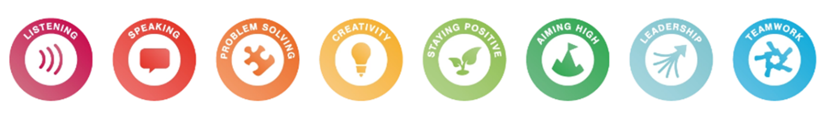

Implementation
The delivery of Skills Builder across our whole-school approach has been meticulously planned to ensure accessibility and meaningful engagement for all pupils. The table below outlines the mechanisms by which Skills Builder is implemented across the school:
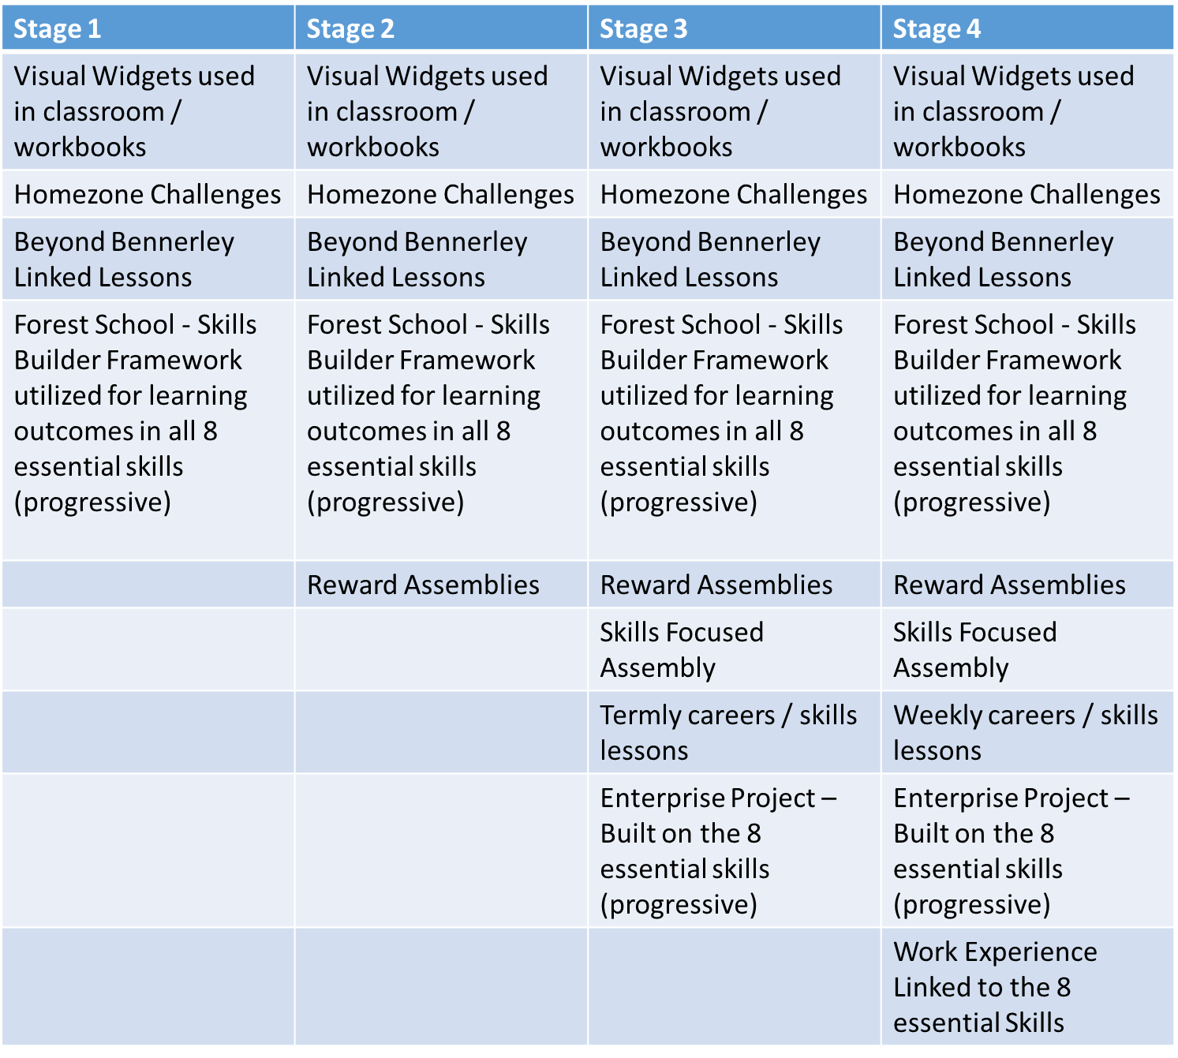

How is Skills Builder Visible Across Our School?
- Marking and Feedback: All marking headers explicitly reference the skills developed during lessons.
Subject:
Date(s):
LO:

Skills Developed:

Level of support for learning:
Continual | Interim |  | Initial |  | Independent
Type of support for learning:
Resources |  | Verbal prompts |  | Gestures  Other:
Physical prompt |  | Questioning
Level of engagement:
High Medium Low

- Rewards System: Rewards are intrinsically linked to the 8 essential skills. Pupils receive stickers, which can be worn on their clothing or placed in their books, celebrating positive engagement. Certificates, distributed by the senior leadership team during reward assemblies, further reinforce these achievements. Staff also contribute to the ‘Shout Out’ board, showcasing examples of positive behaviour and linking these behaviours to the development of specific skills via essential skills widgets.
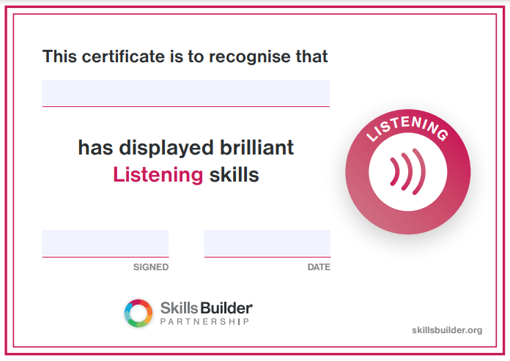

Impact
By embedding frequent opportunities to practice and refine the essential skills, our pupils are well equipped for adulthood. They develop capabilities in collaboration, communication, and maintaining a positive outlook. The curriculum’s strong emphasis on applying skills to real-world contexts ensures pupils are prepared for life beyond Bennerley Fields.
For pupils aiming towards employment, the Skills Builder framework provides a valuable tool to identify and articulate their strengths as they explore career pathways. Through regular reflection on their abilities and progress, pupils build confidence in demonstrating these skills. We actively collaborate with employers to integrate the essential skills into work placements and in-school employer encounters, bridging the gap between education and the workplace.

References
Fair Education Alliance (2023) Fair Education Manifesto 2023.

Times Education Commission (2022) Bringing out the best: How to transform education and unleash the potential of every child.

Ravenscroft, T. (2022) Skills Builder: Handbook for Educators. London: Skills Builder Partnership.

Skills Builder Partnership (2024a) Six principles for building essential skills effectively. Available at: https://www.skillsbuilder.org/principles#:~:text=We%20build%20essential%20skills%20with,experiences%20and%20aspirations%20to%20succeed (Accessed: 19 December 2024).

