Policy Owner: A Shelton
DatePolicyreviewed:Sept 26
Approval Date: TBC
Date of next Review: Sept 27
Approved By: xx

Draft for Approval: 12/Dec/18
Version 1


Attendance policy
Version 1.0

Statutory
Version History
Version | Date Approved | Amendments (Briefly Detail Changes and section/page number) | Substantive or Operational Amendment | Approved By:  Substantive – Trust Board  Operational – Head of Function/CEO
1.0 | 14.9.26 | All amendments made as first version | Substantive | LGC – 8a

Contents
1.0 Aim of this policy 4
2.0 Key principles 4
3.0 Roles and responsibilities 4
3.1 The Academy will: 4
3.2 Parents and carers 6
3.3 Pupils 6
3.4 Senior Attendance Champion 6
3.5 The board of Governors 7
4.0 Registration 7
5.0 Late arrivals 7
6.0 Reasons for absence and how to report or request authorisation 8
6.1 Reporting absence from the Academy 8
6.2 Appointments 8
6.3 Leave of absence (including holidays during term time) 8
6.4 Religious observance 9
7.0 Addressing poor attendance and punctuality 9
Appendix A – Attendance Codes 13
Appendix B – Daily Absence Procedures 15
Appendix C – Graduated Response to Declining Attendance 16
Appendix D - Attendance Contract …………………………………………………………………………………………………………………………….17

Attendance Policy
- Aim of this policy
To support excellent levels of attendance for all pupils to enable fulfilment of their potential at Bennerley Fields.
This policy has been prepared with regard to the Academy’s statutory duties relating to attendance, including those set out in the Department for Education’s statutory guidance entitled Working Together to Improve School Attendance (July 2026), which is referred to in this policy as the “DfE Attendance Guidance”.
- Key principles
- High levels of attendance and punctuality are actively encouraged and recognised.

- It is the responsibility of everybody at Bennerley Fields to improve attendance and punctuality.
- Regular attendance means attending every day you are able.
- Where attendance or punctuality do not meet our Academy’s target 90%, steps will be taken to address this in line with our Graduated Response to Declining Attendance (Appendix C).
- Some pupils find it harder than others to attend school. The Academy will work with pupils, parents and carers, and other local partners to remove any barriers to attendance where possible.
- Subject to the terms of this policy, any day-to-day attendance issues that parents or carers or pupils have should be discussed with class teacher. Where more detailed support around attendance is required, parents and carers and should contact Lisa Hart (Family support and Attendance Team), Anna Shelton (Deputy Headteacher and Attendance Team) or Shirley Sewell (Family support).
- Roles and responsibilities

3.1 The Academy will:
- Develop and maintain a whole academy culture that promotes the benefit of regular attendance including school acknowledging improved attendance and attendance over 90% through positive emails and calls with families. These will also be shared with class teams and pupils (if appropriate). These positive working relationships with families means that attendance and punctuality can be celebrated.
- Work with pupils and their families, building strong relationships, to support high levels of attendance and punctuality and understand any barriers to attendance.
- Investigate unexplained absence, implementing procedures as detailed in Appendix B and C where appropriate.
- Consider individual needs when implementing this policy, including having regard to the Academy’s obligations under the Equality Act 2010 and the UN Convention on the Rights of the Child.
- Share information, including returns information required to be shared in accordance with School Attendance (Pupil Registration) (England) Regulations 2024 and the DfE Attendance Guidance, and work collaboratively with the local authority, other schools in the area, and other partners including, where required, making appropriate referrals in accordance with local procedures, legislation, and guidance.
- Regularly monitor, review, and analyse attendance and absence data, including to identify pupils or cohorts that require attendance support and to set targets for the future.
- Ensure that all pupils can access full-time education (or the equivalent) putting strategies in place where there is evidence to suggest that this is not the case.
- Ensure that the Governors and Bennerley Fields leadership team work together to monitor attendance levels and the effectiveness of this policy.
- Ensure that all legislation and guidance are complied with and reflected in our policies and procedures, including the DfE Attendance Guidance.
- Have in place appropriate safeguarding responses for children who are at risk of missing education, having regard to the statutory guidance Keeping Children Safe in Education (please refer to our child protection policy
- Provide information requested by the Secretary of State, including termly absence data collected by the Department for Education.
- Maintain contact with families where children are not attending due to long-term physical or mental illness, this may include home visits or Teams calls.
- Regularly inform parents and carers about their child’s attendance and absence levels.
- Support pupils who are returning to education following long-term absence.
- Ensure that effective systems to record and report attendance data are in place, including accurate completion of admission and attendance registers, using our electronic management information system (Arbor).
- Assign overall responsibility for championing and improving attendance at the Academy to a designated senior leader, known as the Senior Attendance Champion.
- Observe and fulfil the responsibilities set out in guidance issued by the Department for Education (Summary table of responsibilities for school attendance (applies from 19 August 2024) (publishing.service.gov.uk) to the extent not covered above or elsewhere in this policy.

3.2 Parents and Carers
We expect parents and carers to:
- Ensure that their child arrives at the Academy on time.
- Promote the importance of regular attendance.
- Follow the correct procedure for reporting the absence of their child from the Academy (see section 6.1 below).
- Avoid unnecessary absences.
- Keep the Academy informed of any circumstances which may affect their child’s attendance.
- Not take their child out of education for holidays during term time (see section 6.3 below).
- Inform the Academy in advance of any proposed change of address for their child(ren), along with the name of the parent with whom the child shall live.
- Observe and fulfil their responsibilities set out in the guidance issued by the Department for Education (Summary table of responsibilities for school attendance (applies from 19 August 2024) (publishing.service.gov.uk).

3.3 Pupils
We expect pupils to:
- Attend the Academy regularly and on time.
- Be punctual to all lessons (where applicable).
- Follow the correct procedure if they arrive to the Academy late (see sections 5 below).

3.4 Senior Attendance Champion
The Senior Attendance Champion (“SAC”) at the Academy is Anna Shelton (Deputy Headteacher and DSL)
The SAC has overall responsibility for championing and improving attendance at the Academy and will:
- Set a clear vision for improving and maintaining good attendance.
- Establish and maintain effective systems for tackling absence and ensure that these are followed by all staff.
- Evaluate and monitor attendance expectations and processes.
- Have a strong grasp of absence data to focus the collective efforts of the Academy.
- Ensure that key attendance messages are communicated to parents and carers and pupils (if appropriate).
- Provide data and reports to support the work of the SLT and Governors.

3.5 The board of Governors
The board of Governors will:
- Take an active role in attendance improvement, recognise the importance of school attendance, and promote it across the trust and Academy’s ethos and policies.
- Ensure the Academy’s leaders fulfil expectations and statutory duties.
- Regularly review attendance data, discuss and challenge trends, and help Academy leaders focus improvement efforts on the individual pupils or cohorts who need it most.
- Ensure Academy staff receive adequate training on attendance, including dedicated training for staff with specific attendance responsibilities and any additional training that would help support pupils or cohorts to overcome common barriers to attendance.
- Hold termly attendance review meetings with the Academy lead for attendance and share this regularly at Governors meetings.

- Registration
- The Academy maintains an attendance register and uses this to record each pupil’s attendance at the start of the school day and again in the afternoon.
Morning Registration
8:55am School Opens
9:00am Registration Begins
9:20am Pupils arriving after this time will receive a Late mark (L) (unless it is Transport related)
9:30am Registration Closes pupils arriving after this time will receive an Unauthorised Absence (U)
Afternoon Registration
1:00pm Registration Begins
1:20pm Registration Closes
- The register is marked using the national statutory attendance and absence codes which can be found in the DfE Attendance Guidance or Appendix A.
- Late arrivals
- If a pupil arrives after registration has closed for the morning or afternoon session, they must report to the school office as soon as they arrive and explain the reason for their lateness. This will enable the school to record the appropriate attendance code. Where no satisfactory reason is provided, the absence may be recorded as unauthorised.

- Where lateness becomes a recurring concern, the Academy will work with pupils and parents/carers to address the issue in line with the behaviour policy.

- Reasons for absence and how to report or request authorisation
Authorised absence – absence will only be authorised where the Academy has given approval in advance for a pupil to not be in attendance or has accepted an explanation offered afterwards as justification for the absence. Only the Academy can authorise absence.
Unauthorised absence – absence will be marked as unauthorised where the Academy is not satisfied with the reasons given for the absence.

6.1 Reporting absence from the Academy
- Where a pupil is to be absent from the Academy without prior permission, the parent/carer should inform the Academy by telephone on the morning of the day of the first absence and let the Academy know when they expect the pupil to return. If the return date is not confirmed on the first day of absence, parents/carers must contact the Academy on each day of absence.
- Any unexplained absence will be followed up by the Academy promptly.
- In cases where the Academy needs clarification to accurately record the absence in the attendance register, the parents/carers may be asked to provide the Academy with medical evidence, such as a note from the child’s doctor to support an absence for illness. If satisfactory evidence is not provided, the absence may be marked as unauthorised. Where there are prolonged or repeated patterns of illness, medical evidence may also be requested to support the Academy’s understanding of a pupil’s health needs and to ensure that appropriate support and/or adjustments are put in place (please refer to our policy on supporting pupils with medical conditions)

6.2 Appointments
- Medical, dental, and other essential appointments for a pupil should take place outside of school hours where this is reasonably possible.
- Where an appointment must take place during school time, the pupil should attend the Academy for as much of the day as possible and as much prior notice as possible should be given to class teacher or school office.
- Pupils who have attended a doctor’s or dentist appointment and subsequently come into school later than 9:30 will have the absence recorded as a medical absence (Attendance Code M)

6.3 Leave of absence (including holidays during term time)
- The Academy will grant permission for a pupil to be absent from school in the circumstances described in paragraph 36 of the DfE Attendance Guidance which can be summarised as follows:
- Taking part in a regulated performance or employment abroad.
- Attendance at an interview for entry into another educational setting or future employment.
- Study leave for public examinations.
- Temporary, time-limited part-time timetable.
- Other exceptional circumstances, which will be decided upon based on the individual merits of each case.
- Parents/Carers should make every effort to avoid taking pupils out of education for holidays or other extended leave during term time.
- To request a leave of absence, parents/carers must make the request in advance and in writing addressed to the headteacher and, wherever possible, at least four school weeks ahead of the planned leave.
- Where a leave of absence is requested as above, the headteacher will consider the specific facts and circumstances relating to the request. The decision:
- Will be confirmed in writing.
- Is solely at the headteacher’s discretion.
- Is final.
- Where permission is granted, the headteacher will confirm the number of days and dates of absence which are authorised.
- If permission is not granted and the parents/carers proceed to take their child out of the Academy, the absence will be marked as unauthorised, and parents may be issued with a penalty notice or be subject to prosecution by the local authority (see section 7 below).

6.4 Religious observance
- We recognise that pupils of certain faiths may need to participate in days of religious observance. Absence from the Academy will be authorised where a day of religious observance:
- Falls during school time.
- Has been exclusively set apart for religious observance by the religious body to which the pupil belongs.
- We ask that parents/carers notify the Academy by writing to Jenni Wright (Headteacher) in advance where absence is required due to religious observance.
- Addressing poor attendance and punctuality
The Academy will use data to target attendance improvement efforts to the pupils or groups of pupils who need it most. In doing so, the Academy, led by the SAC, will:
- Monitor and analyse weekly attendance patterns, proactively using data to identify pupils at risk of poor attendance and changes in attendance at individual pupil, cohort, and year group level to support early intervention.
- Provide regular attendance reports to class teachers and relevant leaders.
- Identify pupils who need support from wider partners, as soon as possible, and deliver this support in a targeted manner.
- Conduct thorough analysis of half-termly, termly, and full-year data to identify patterns and trends.
- Benchmark Academy attendance data at each level against local, regional, and national level.
- Monitor the impact of Academy strategies and actions to improve attendance on particular pupils and particular groups.
- Work with the local authority and other local partners to identify groups.
- Hold regular meetings with the parents or carers of pupils who the Academy and/or local authority consider would benefit from targeted support.
- Our procedures for managing unexplained absences can be found in Appendix B.
- Where absence or punctuality is a cause for concern, for example because there is:
- A pattern of unauthorised absence.
- A question over the reasons provided for a particular absence or late arrival.
- Persistent lateness
- We will contact the parents/carers with a view to working together to support improved attendance and/or punctuality.
- In cases where the Academy has been unable to establish a clear reason for absence and/or has welfare concerns about the pupil, a home welfare check may be carried out.
- Absence will be classed as persistent where it falls below 90% across the academic year. Absence at this level is very likely to hinder educational prospects and we expect full parental cooperation and support to urgently address these cases. Intervention steps may include implementation of an attendance action plan, referral to other agencies, and/or seeking to put in place an attendance contract (please see Appendix C and Appendix D).
- Where out-of-school barriers to attendance are identified, the Academy will signpost and support access to any additional services.
- Where parents/carers have failed to ensure that their child of compulsory school age is regularly attending the Academy, and wider support in accordance with this policy is not appropriate or effective, we may consider issuing a penalty notice. A penalty notice is a financial penalty (£80 if paid within 21 days; £160 if paid within 28 days) imposed on parents, which is intended to change behaviour without the need for criminal prosecution.
- When considering whether to issue a penalty notice, we will have regard to:
- The National Framework for penalty notices as set out in paragraphs 179–205 of the DfE Attendance Guidance.
- The local authority’s code of conduct for issuing penalty notices.
- If a penalty notice is issued but is not paid within 28 days, the local authority will decide whether to proceed to prosecution. The local authority also has separate powers to prosecute parents if their child of compulsory school age fails to attend school regularly.

Appendix A – Attendance Codes

ATTENDANCE CODES, DESCRIPTIONS AND MEANINGS
CODE | DESCRIPTION | MEANING
/ | Present (AM) | Present
\ | Present (PM) | Present
B | Educated off site (NOT Dual registration. Pupil must be physically attending and excludes virtual learning) | Approved Education Activity
C | Other Authorised Circumstances (not covered by another appropriate code/description) | Authorised absence
C1 | Participating in a regulated performance or undertaking regulated employment abroad | Authorised absence
C2 | Part-time timetable | Authorised absence
D | Dual registered | Approved Education setting
E | Excluded or Suspended (no alternative provision made) | Authorised absence
G | Family holiday (NOT agreed or days in excess of agreement) | Unauthorised absence
I | Illness (NOT medical or dental etc. appointments. Physical or Mental). | Authorised absence
J1 | Interview or admission to another educational institution | Approved Education Activity
K | Attending education provision arranged by the local authority | Approved Education by LA
L | Late (before registers closed) | Present
M | Medical/Dental appointments | Authorised absence
N | No reason yet provided for absence | Unauthorised absence
O | Unauthorised absence (not covered by any other code/description) | Unauthorised absence
P | Approved sporting activity | Approved Education Activity
Q | Lack of access arrangements (LA failed to make access arrangements). | Authorised absence
R | Religious observance | Authorised absence
S | Study leave | Authorised absence
T | Parent travelling for occupational purposes (pupil is a mobile child) | Authorised absence
U | Late (after registers closed) | Unauthorised absence
V | Educational visit or trip | Approved Education Activity
W | Work experience | Approved Education Activity
D | Dual registration (i.e. pupil attending other establishment) | Not counted in possible attendances
X | Not required to be in school (pupil is non-compulsory school age is not required to attend)
Y1 | Transport not available | Absent – unavoidable cause
Y2 | Widespread disruption to travel | Absent – unavoidable cause
Y3 | Part of school premises closed | Absent – unavoidable cause
Y4 | Whole school site unexpectedly closed | Absent – unavoidable cause
Y5 | Criminal justice detention | Absent – unavoidable cause
Y6 | Public health guidance or law | Absent – unavoidable cause
Y7 | Any other unavoidable cause | Absent – unavoidable cause
Z | Pupil not yet on roll | Not counted in possible attendances
# | School closed to pupils | Not counted in possible attendances

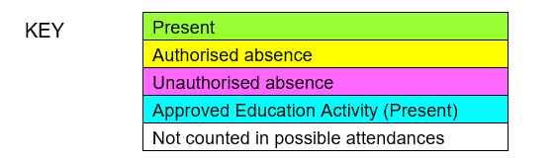

Definitions
Authorised absence - An absence is classified as authorised when a child has been away from school for a legitimate unavoidable reason and the school has received notification from a parent or carer. For example, if a child has been unwell and the parent telephones the school to explain absence.
Sometimes, even if absence is supported by parent/carer, an absence will be unauthorised, e.g. if a child refuses to attend.
Unauthorised absence - An absence is classified as unauthorised when a child is away from school without permission of the school, even if the absence is supported by the parent/carer.
Persistent Absence (PA) – Missing 10% or more of schooling
Severe Absence (SA) - Missing 50% or more of schooling.

Appendix B – Daily Absence Procedures

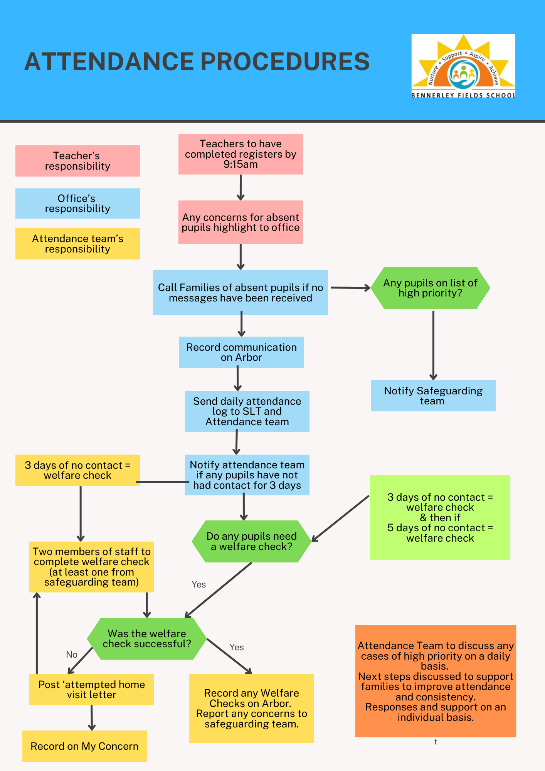

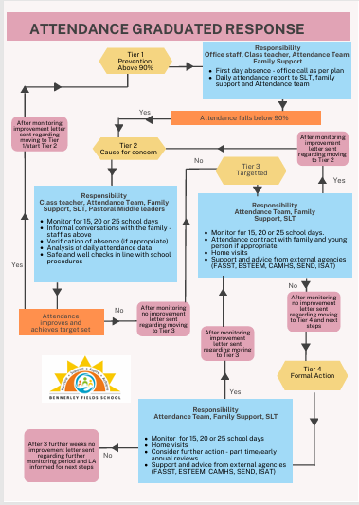
Appendix C – Graduated Response to Declining Attendance

Appendix D – Attendance Contract Template

Attendance Contract
Date/time of meeting
Tier and number (first/second)
Venue

Pupil name
Date of Birth and Year Group
Present at meeting

Barriers/Concerns regarding attendance

Action Agreed

Current Attendance:
Attendance Target:
Timescale for Improvement
Date for Review

I confirm that this Attendance Action Plan was agreed by all present.
Parent/Carer…………………………………………………………………………………………..
Pupil (if applicable) ………………………………………………………………………………….
School Representative ……………………………………………………………………………..
Other Agency ………………………………………………………………………………………….

